Annex A5 - Web Update
In its multi-nation, episodic drama The Team, Search for Common Ground has merged the global appeal of football with soap opera to help transform social attitudes and diminish violent behavior in countries grappling with deeply rooted conflict. The television series addresses the very real divisive issues facing societies in a dozen African, Asian and Middle Eastern countries, using sport as a unifier to surmount barriers. Each production of The Team follows the characters on a football team who must overcome their differences – be they cultural, ethnic, religious, tribal, racial or socio-economic – in order to work together to win the game.

2010-2011 GTF Annual Report : http:www.sfcg.org
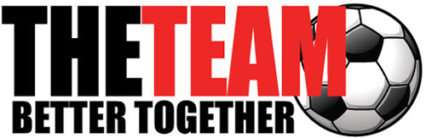 | SFCG The Team Global website - http://www.sfcg.org/programmes/cgp/the-team.html  SFCG YouTube page with music videos and short clips of scenes from episodes http://www.youtube.com/results?search_query=Search+for+common+ground+The+team&aq=f
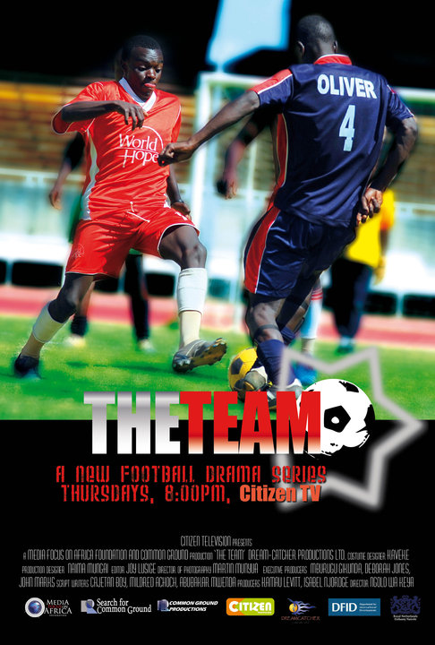 | The Team: Kenya website - http://www.theteamkenya.com  Kenya Twitter Page - http://twitter.com/#!/ImaniFc  Kenya Facebook Page - http://www.facebook.com/group.php?gid=78560763554&v=wall  Kenya YouTube site - http://www.youtube.com/theteamkenya
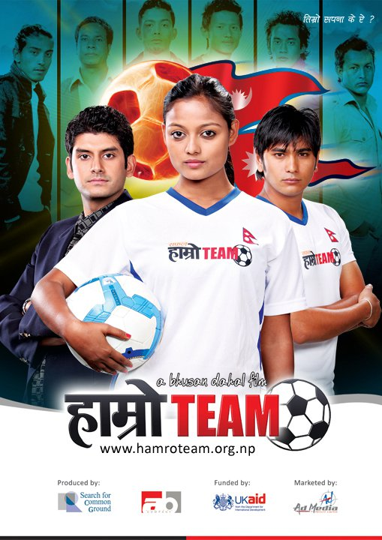 | The Team: Nepal website - http://hamroteam.org.np/team-nepal  Nepal Facebook page. - http://www.facebook.com/teamnepal  Nepal’s YouTube site. - http://www.youtube.com/watch?v=jAOOrd52yKk
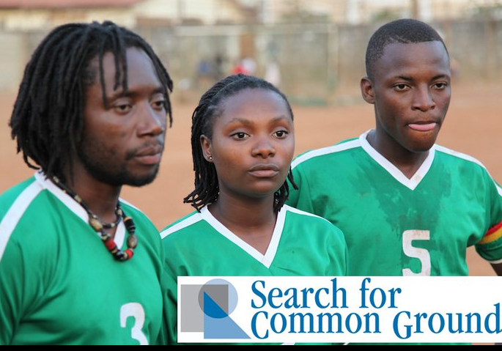 | The Team: Sierra Leone Facebook Page - http://www.facebook.com/pages/The-Team-Sierra-Leone/154342211300154
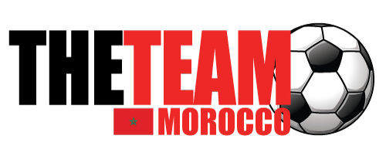 | The Team: Morocco website (in Arabic) - http://www.tanmia.ma/lequipe/

